1.Log in to your home Wi-Fi router's admin panel using its default IP address (usually 192.168.0.1 or 192.168.1.1) and take a screenshot of the login page.<br><br><em><strong>Hint:</strong> If you don't know your router's IP, open Command Prompt and run 'ipconfig' — look for 'Default Gateway'.</em>
First, I opened Command Prompt and typed the command ipconfig. I found the Default Gateway address as 192.168.0.1. Then, I opened Google Chrome and entered 192.168.0.1 in the address bar.
The router login page of the Tenda Wi-Fi Router appeared, asking for the login password. I took a screenshot of the login page.
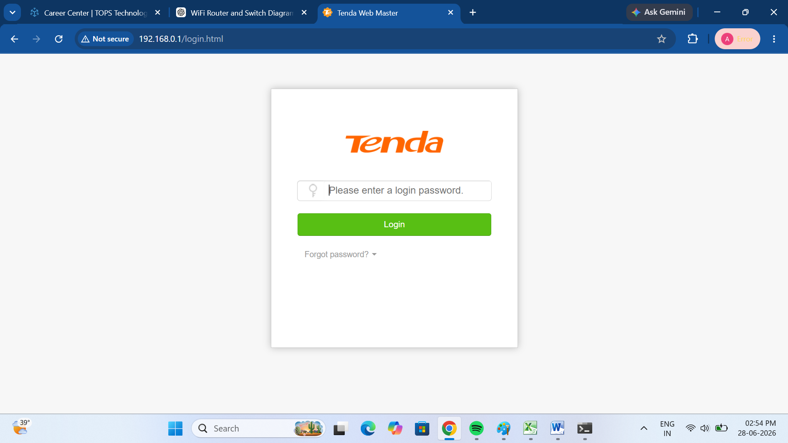

2.Find and note down the current IP address, subnet mask, and default gateway assigned to your laptop or mobile device when connected to your Wi-Fi network
->To find the network information of my laptop, I connected my laptop to the Wi-Fi network. Then, I opened Command Prompt and typed the command ipconfig. After pressing Enter, I noted down the IP address, subnet mask, and default gateway.
The details are as follows:
- IP Address: 192.168.0.125
- Subnet Mask: 255.255.255.0
- Default Gateway: 192.168.0.1
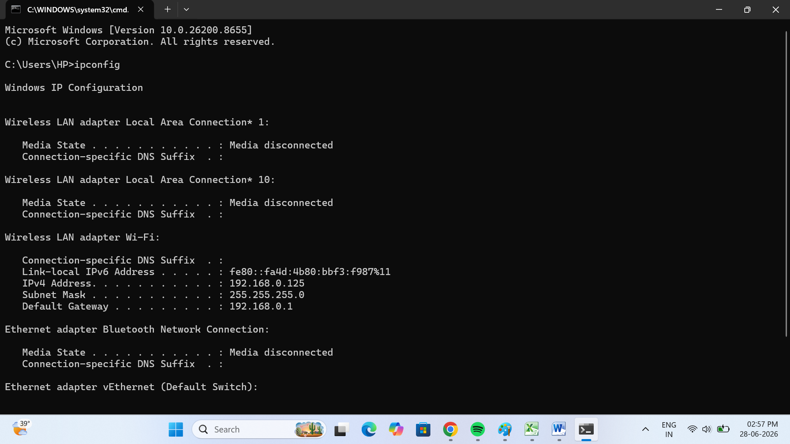
3.Change your device's IP address from 'Obtain IP automatically' (DHCP) to a static IP in the same range as your router (for example, set it to 192.168.1.50 if your router is 192.168.1.1), and test if you still have internet access.<br><br><em><strong>Constraint:</strong> Remember to revert to automatic/DHCP after testing to avoid network issues.</em>

->I changed my laptop's network settings from DHCP to a static IP address.
The following settings were configured:
- IP Address: 192.168.0.50
- Subnet Mask: 255.255.255.0
- Default Gateway: 192.168.0.1
- Preferred DNS Server: 8.8.8.8
- Alternate DNS Server: 8.8.4.4
After applying the settings, I opened Google Chrome and verified that the Internet connection was still working properly.
After testing, I changed the settings back to Obtain an IP address automatically (DHCP) to avoid network issues.

4.In your router's admin panel, locate the section where you can view or change the DHCP range. Write down the current range, and explain in 2-3 lines what would happen if two devices are assigned the same IP address in this range.

-> DHCP Range(Example):
Start IP:192.168.1.100
End IP:192.168.1.199
Explanation:
If two devices are assigned the same IP address conflict occurs.This can cause one or both devices to lose network or internet connectivity ,and they may not be able to communicate properly with the router or other devices on the network.
:Replace the example DHCP range(192.168.1.100 – 192.168.1.199) with the actual range shown in your router’s DHCP settings.

